CHAPTER 10: Transferring and transforming energy
Worksheet 10.4

Light energy
Student: Class:
1. The incandescent light bulb
The diagram shows an incandescent light bulb.
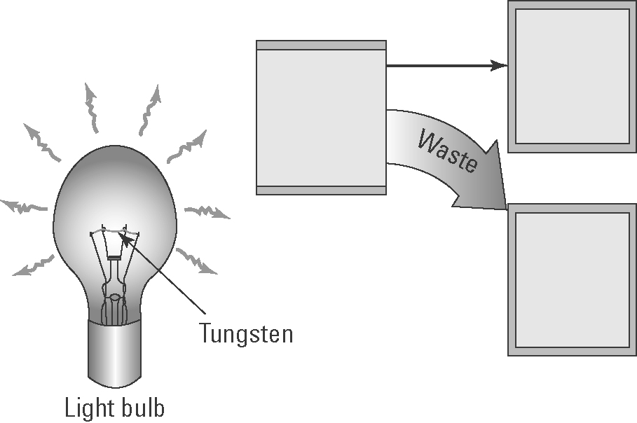
(a) Explain how an incandescent light bulb generates light.

(b) Insert the following words in the boxes in the diagram:
heat energy, electrical energy, light energy
(c) Explain why these light bulbs are not energy efficient.

2. Measuring reflected light
The diagram below shows the procedure used by a student to measure the intensity of reflected light from various materials and compare it with light reflected by a normal mirror.
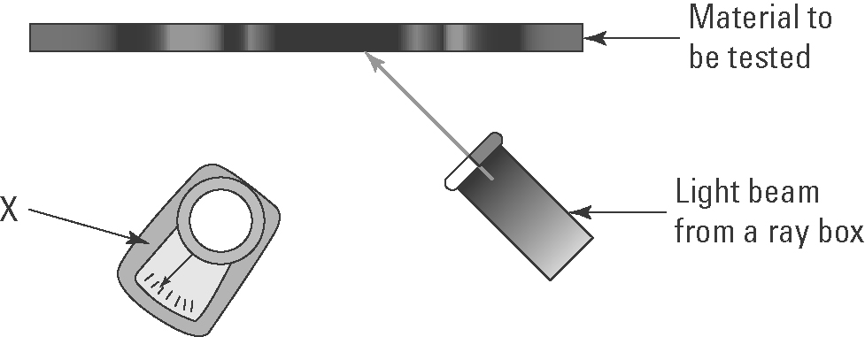
(a) Identify the measuring device X.
(b) Why is a normal mirror also tested?

(c) Identify the variables that need to be controlled.

(d) The following materials were tested: shiny white cardboard, dull black cardboard and shiny black cardboard. Predict which cards will reflect the:
(i) most light energy ..........................................
(ii) least light energy. ..........................................

